Unit Three My Friends第四课时
学习内容：B Let's talk
学习目标：
1,Knowledge aims:By ending of the class the students will be able to understand ,read and speak“He’s…..He has…….His shoes are…”and can ask “Who’s he? Is he…?”
２,Skill aims:The students will be able to describe friends and guess friends by using the sentence structure
3，Emotion aim:let them know “make friends in your life make your life colourful”

学习重点：1, 能够在实际生活中，结合一定的语言情景描述朋友的特征
2，能正确运用he ,his,she,her这些代词与物主代词教学难点：Chinese, his的尾音
一、开动脑筋，你一定能填上。(20分)
1．m____s____c(音乐)
2．sp____ ____ts(运动)
3．sc____e____ce(科学)
4．p____i____ting(绘画)
二、火眼金睛，选一选。(35分)
( )1.I________music.
A．likes B．like C．to like
( )2.He likes________.
A．computer games
B．read a book
C．Computer
( )3.Please have________try!
A．a B．an C．/
( )4.Please help________.
A．I B．me C．my
( )5.She likes________.
A．paint B．paints
C．painting
( )6.Bill and Mike like ________ chess.
A．playing B．do
C．plays
( )7.Mary is looking at the picture.He wants to ________ it.
A．painting B．paint
C．paints
三、你会搭配吗？ (40分)
1.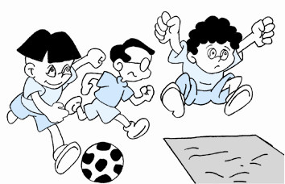 2.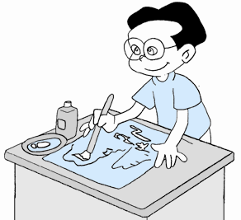
( ) ( )
3.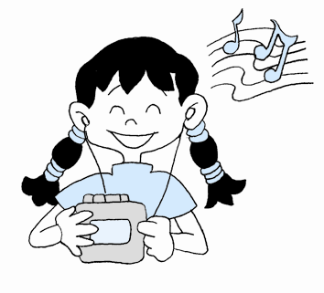 4.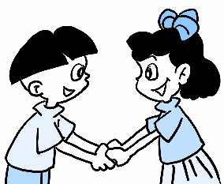
( ) ( )
A．Painting. B．Make friends.
C．Listen to music. D．Do sports.
四、你知道吗？(5分)
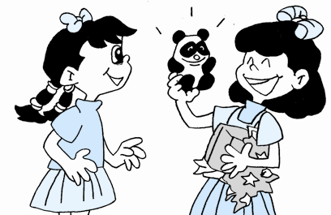
( )当一个朋友送你礼物时，你应说： ________
A．Thank you.
B．You're welcome.

参考答案
